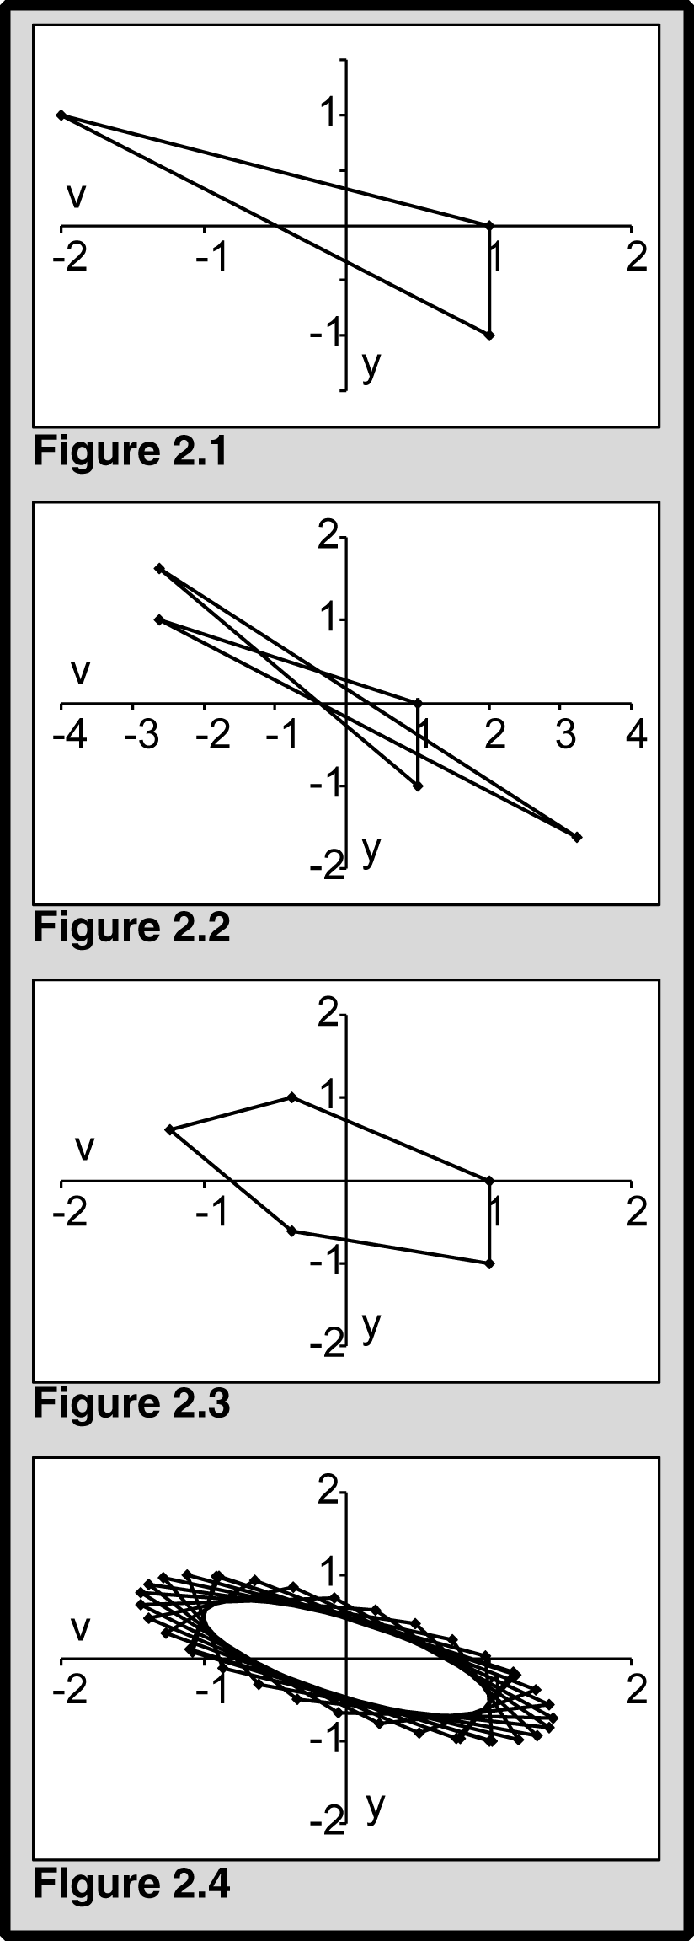

Figures 2.1 - 2.3 depict the cyclic trajectory of a nonrandom particle when ϕ = 3 (Fig. 2.1), 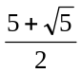 (Fig. 2.2), and 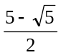 (Fig. 2.3). Figure 2.4 depicts the particle’s more typical quasicyclic behavior when ϕ does not satisfy Equ.2.11. Here ϕ =2.1.

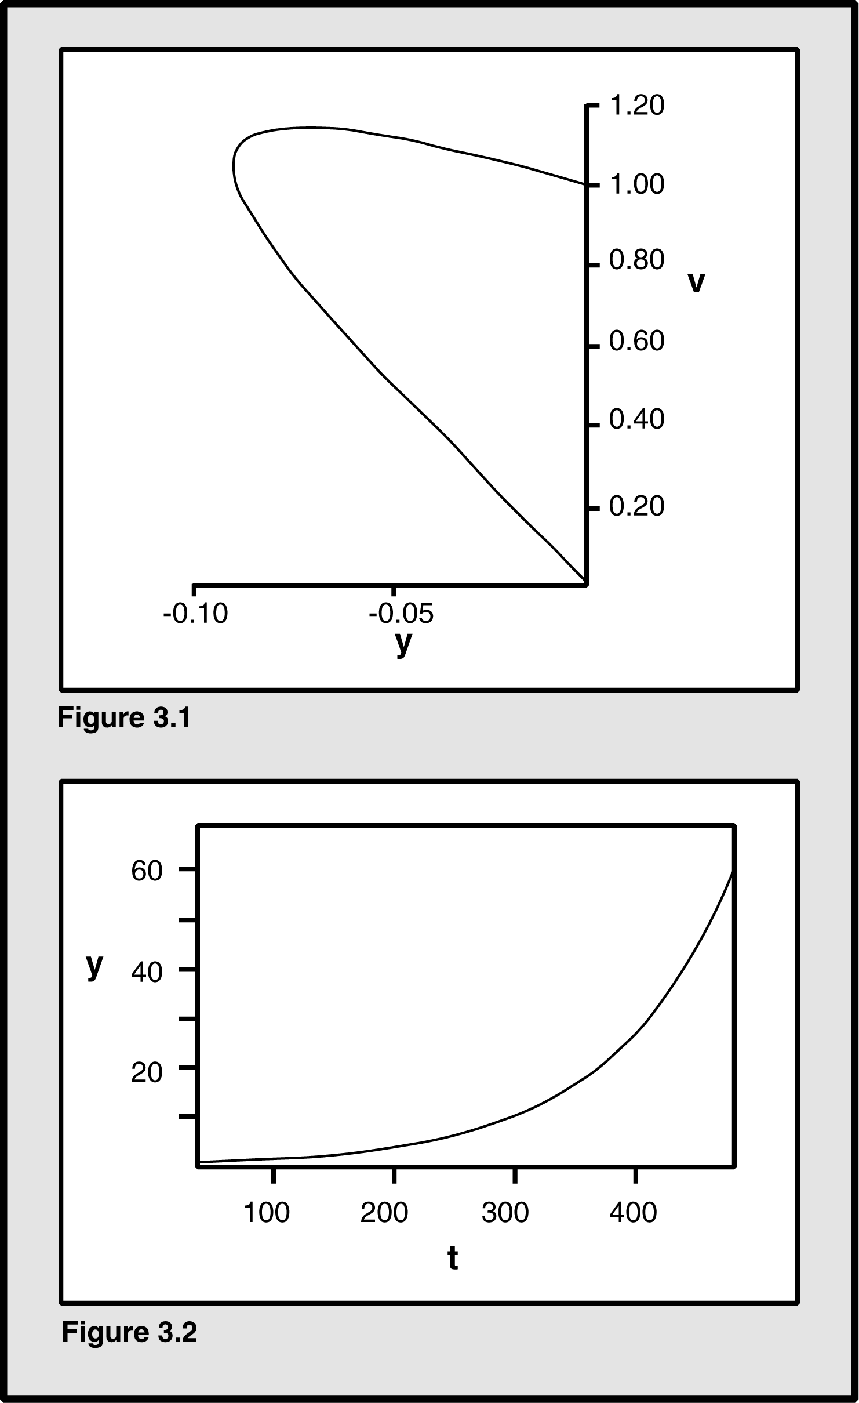

Figure 3.1 demonstrates the convergent trajectory in phase space of a particle when 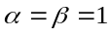 and 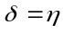,
where 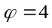. Both velocity v and y, the difference between the previous best p and the current position x, converge to 0.0. In Figure 3.2, y increases over time, even when the parameters are real and not complex.
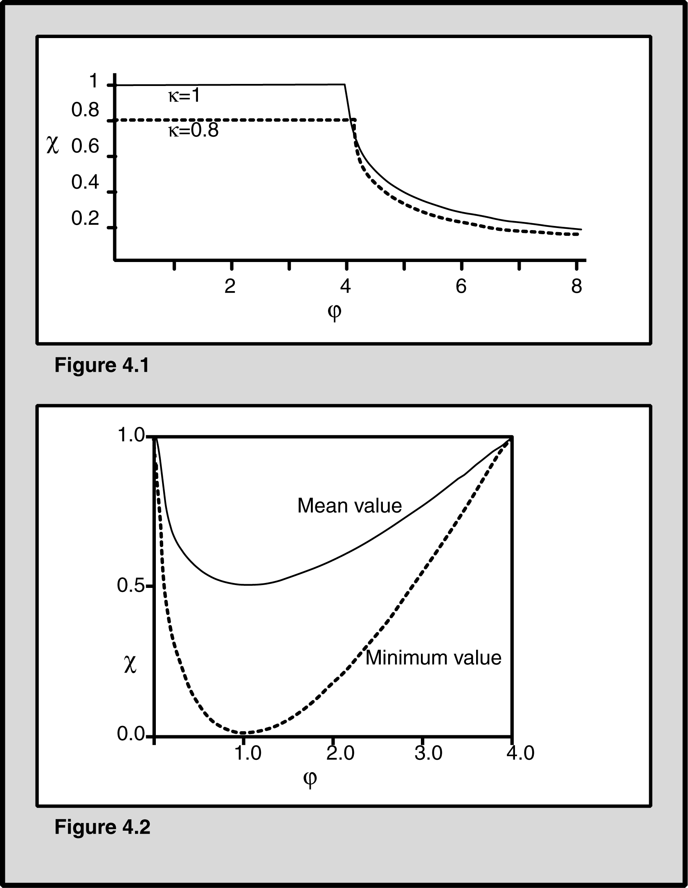

Figure 4.1 shows the Type 1 constriction coefficient χ as a function of ϕ and κ. It drops below κ only when ϕ >4.0. The Type 1′ coefficient is less than 1.0 when ϕ <4.0. These coefficients identify the conditions for convergence of the particle system.

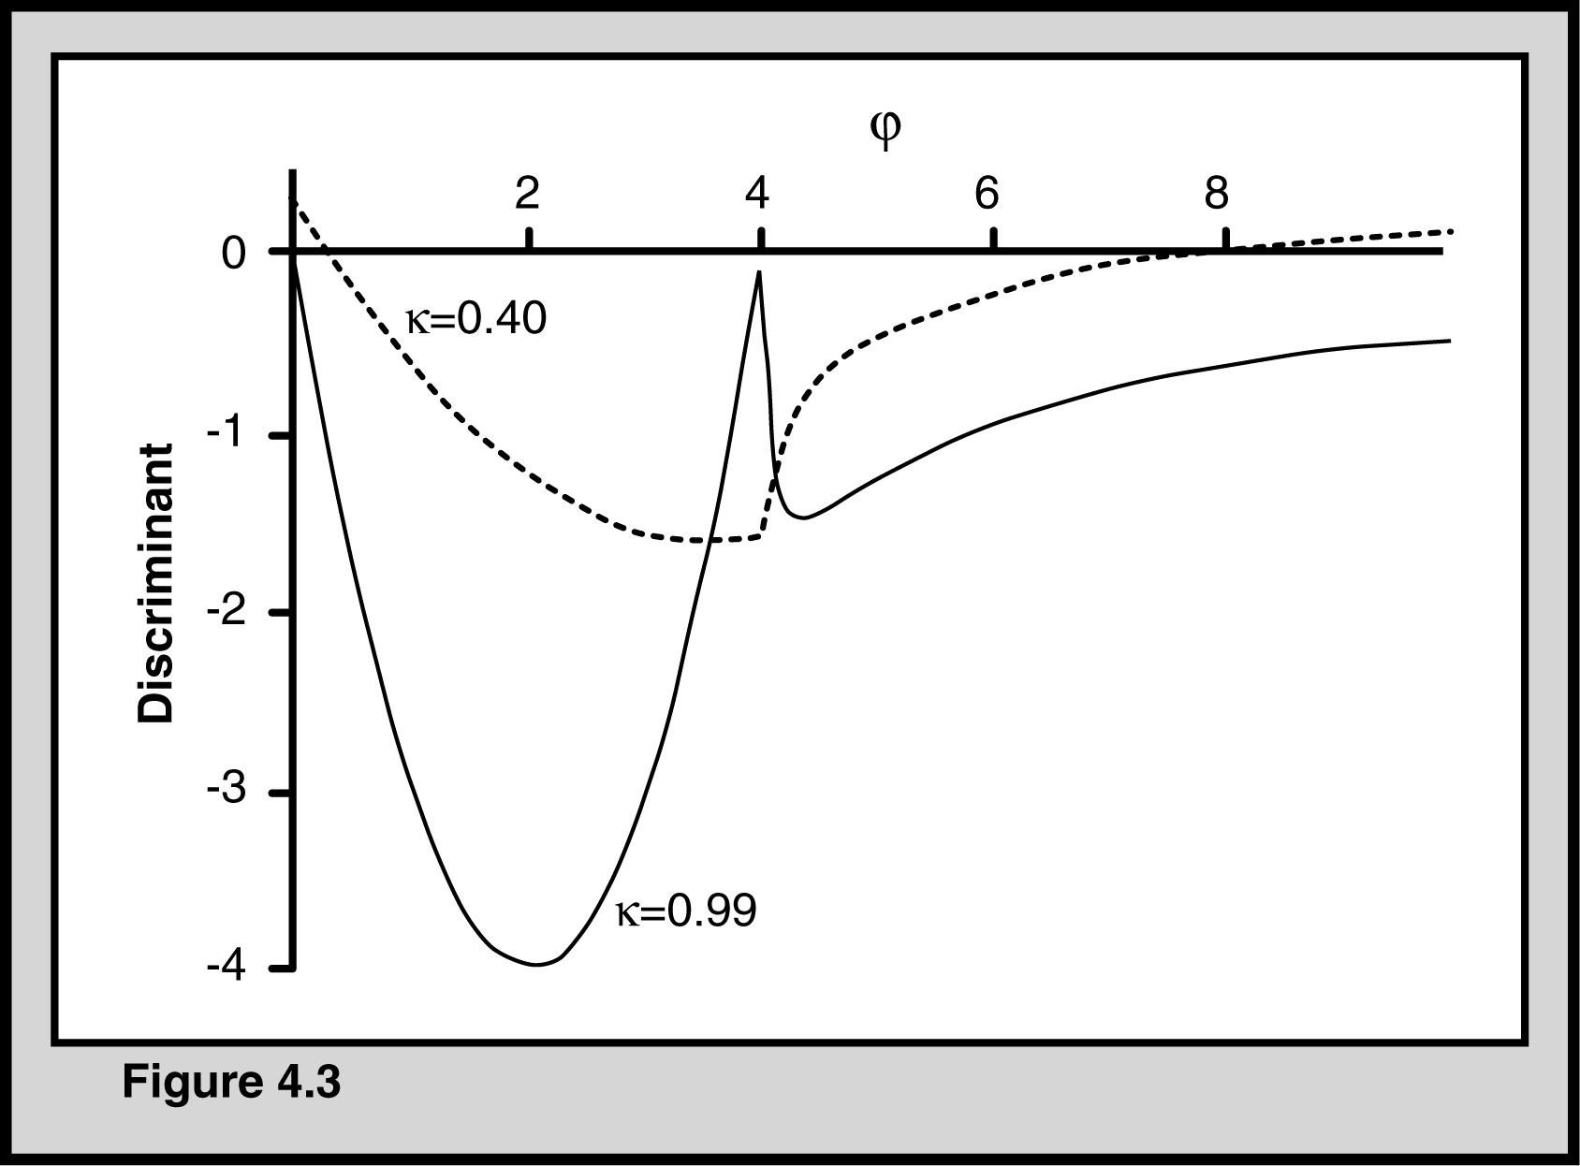

As Figure 4.3 shows, the discriminant remains negative within some bounds of ϕ , depending on the value of κ, ensuring that the particle system will eventually converge.

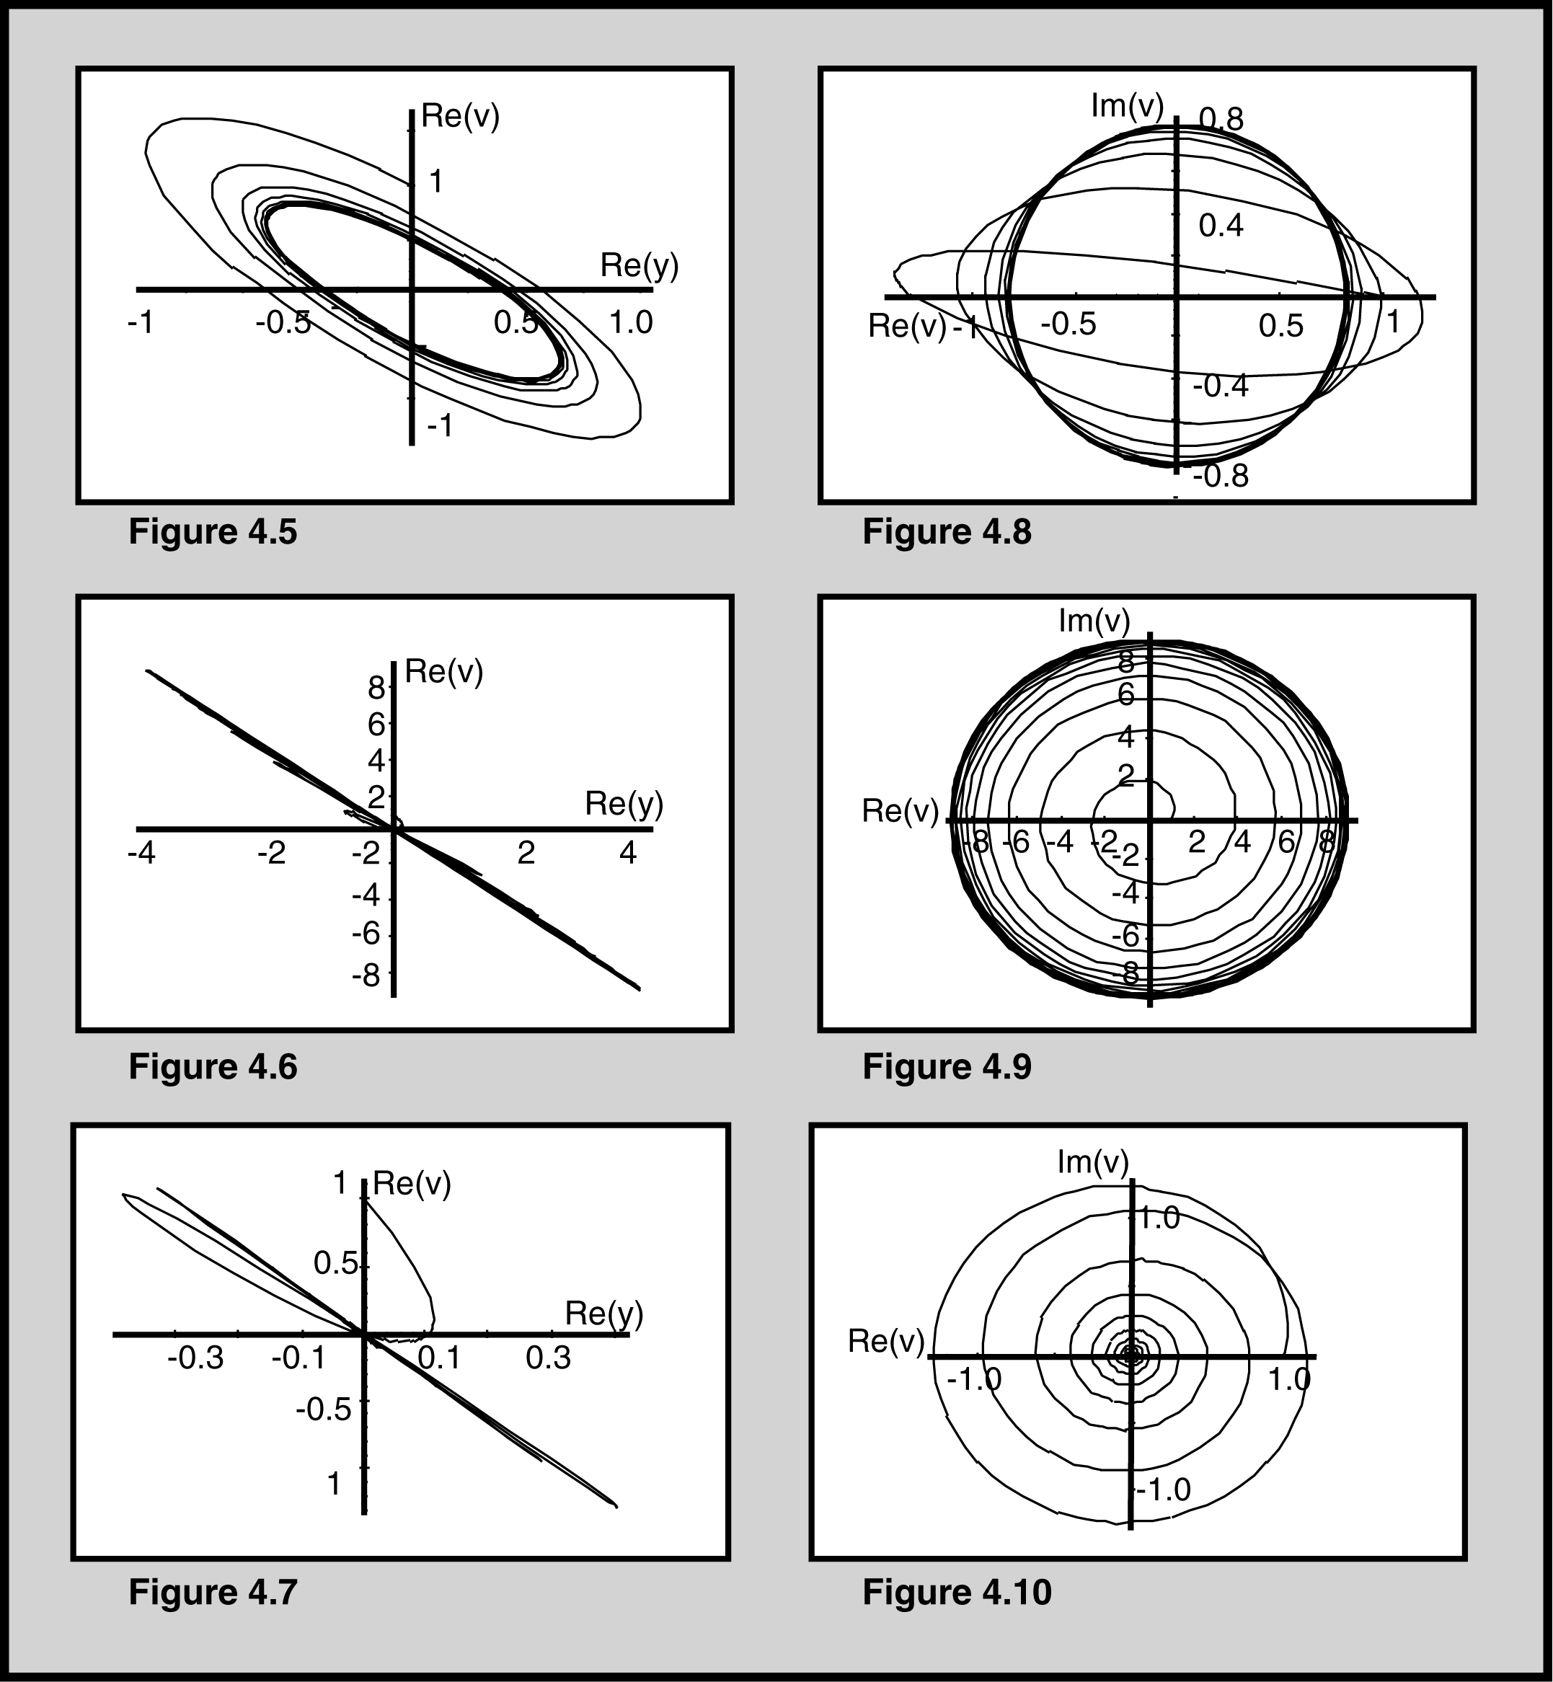

Figures 4.5-4.10 show views of the trajectories of a particle in phase space with three different values of ϕ. The views on the left show the real parts of the velocity v and position relative to the previous best y, and the figures on the right show the real and imaginary parts of v.

Figures 4.5 and 4.8 show the attractor for a particle with ϕ = 2.5. The particle tends to orbit, rather than converging to 0.0. Figures 4.6 and 4.9 show the same views with ϕ = 3.99. Figures 4.7 and 4.10 depict the “easy” convergence toward 0.0 of a constricted particle with ϕ = 6.0. The particle oscillates with quickly-decaying amplitude toward a point in the phase space (and the search space).

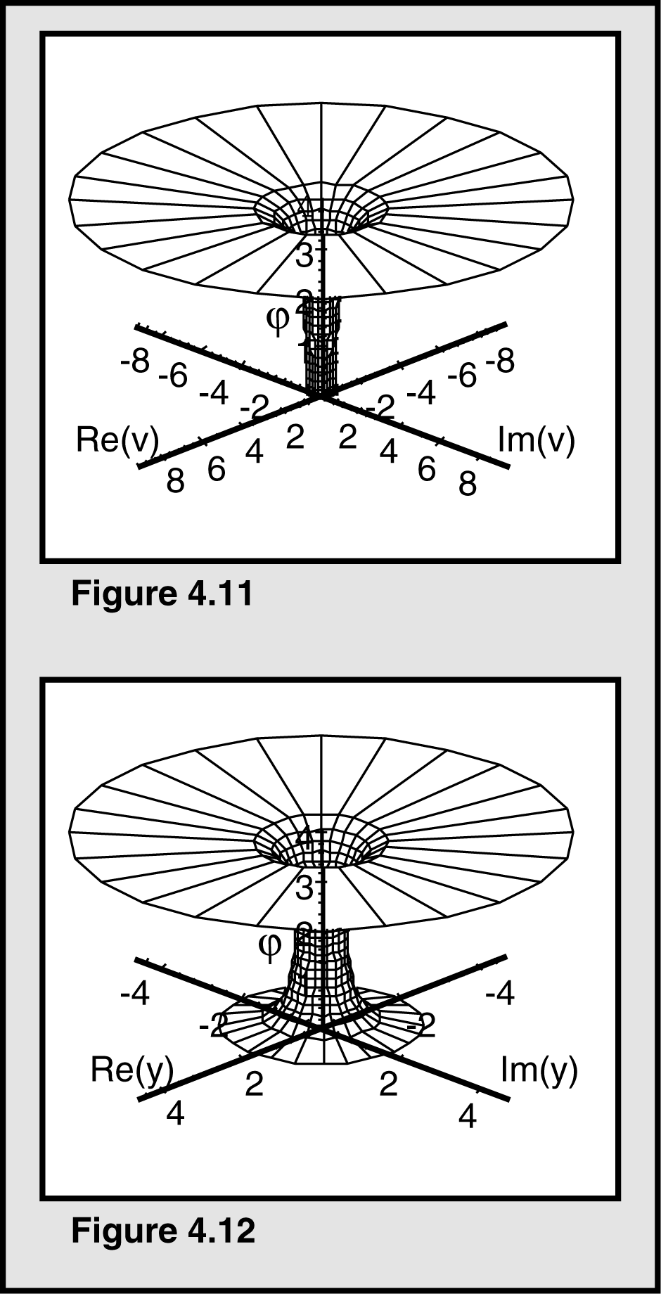

Figures 4.11 and 4.12 show the “trumpet” global attractor when ϕ < 4; Figure 4.11 shows the effect on ϕ of the real and imaginary parts of v, while Figure 4.12 shows the effects of the real and imaginary parts of y.

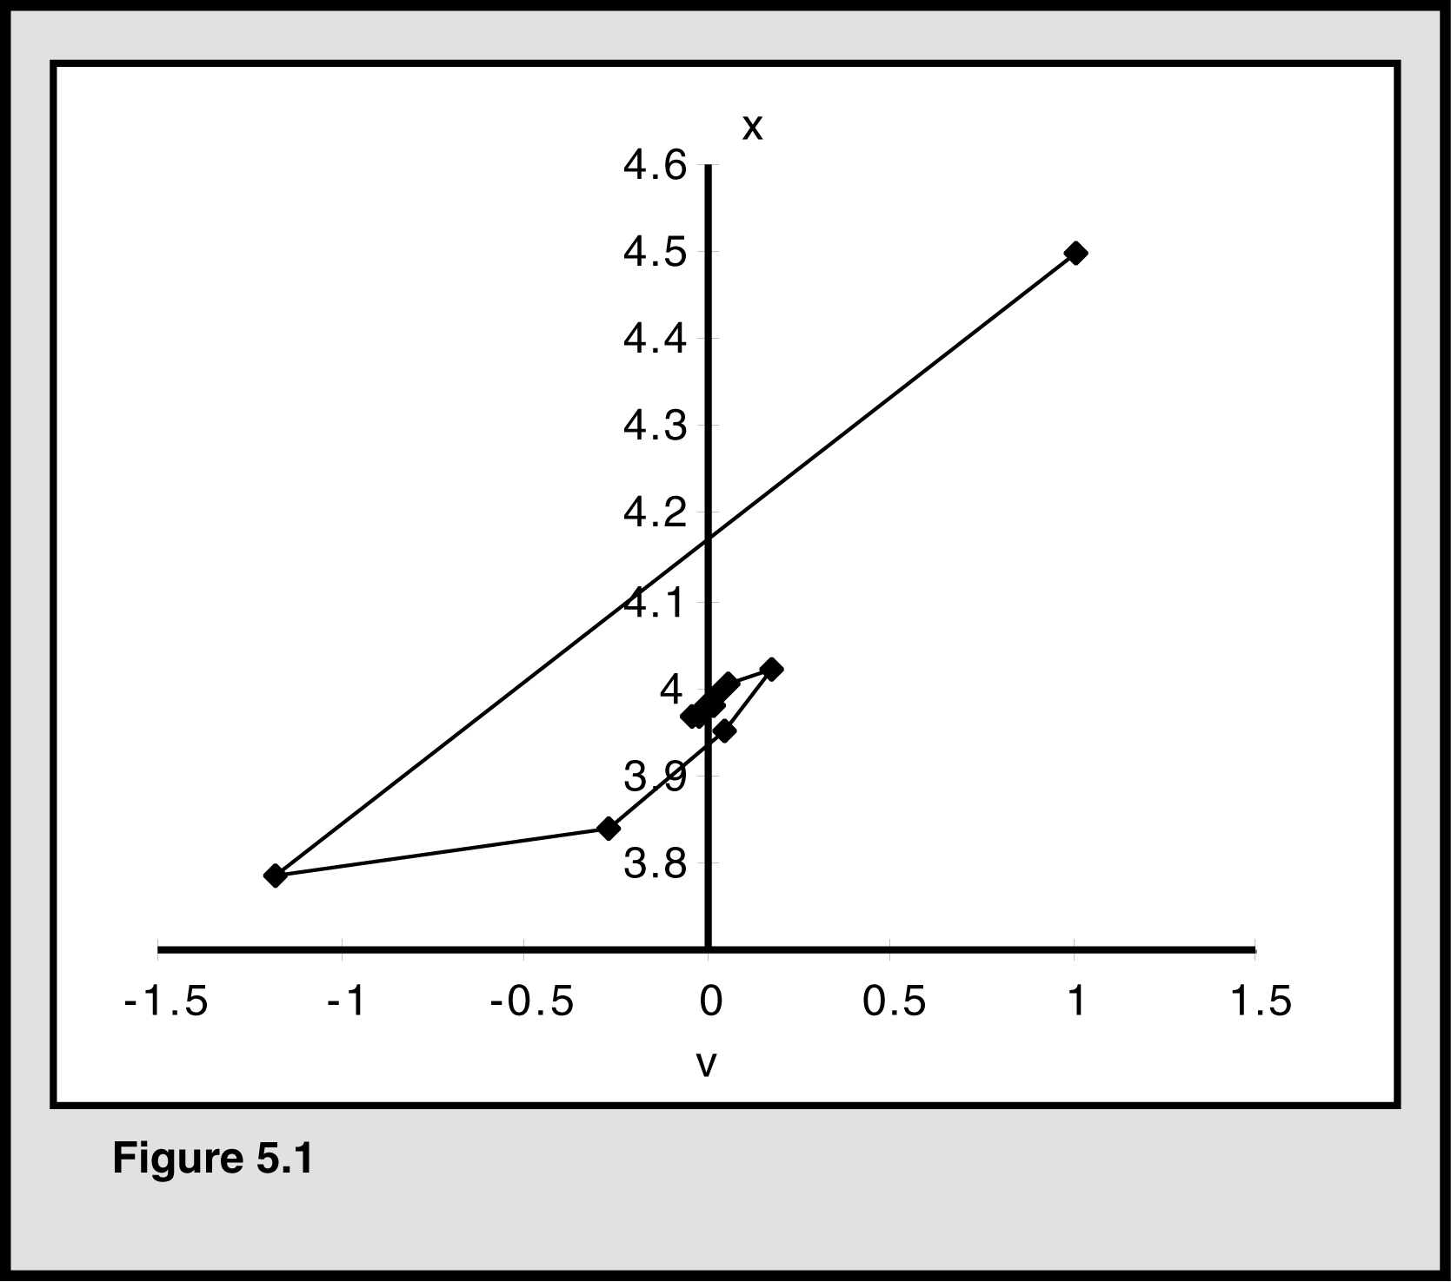

Figure 5.1 shows an example of the trajectory of a particle with the “original” formula containing two 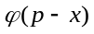 terms, where ϕ is the upper limit of a uniform random variable. As can be seen, velocity v converges to 0.0, and the particle’s position x converges on the previous best point, p.

